TASK 11 — Comparative Analysis of Zero-shot, One-shot and Few-shot Prompting
AIM
To generate responses for the same task using Zero-shot, One-shot, and Few-shot prompting and compare the responses based on quality, relevance, accuracy, and consistency.
PROCEDURE
1. Select one common task for all three prompting strategies.
2. Create a Zero-shot prompt without examples.
3. Create a One-shot prompt containing one example.
4. Create a Few-shot prompt containing multiple examples.
5. Submit all prompts to the LLM using the same task.
6. Record the generated responses.
7. Evaluate the responses using relevance, accuracy, completeness, clarity, and consistency.
8. Compare the scores and identify the best-performing prompting strategy.
PROMPT
TASK: Generate a Python program to check whether a number is a palindrome.
ZERO-SHOT:
Write a Python program to check whether a given number is a palindrome.
ONE-SHOT:
Example:
Input: 121
Output: 121 is a palindrome
Now write a Python program that accepts a number and checks whether it is a palindrome.
FEW-SHOT:
Examples:
Input: 121 -> 121 is a palindrome
Input: 123 -> 123 is not a palindrome
Input: 1221 -> 1221 is a palindrome
Now write a Python 3 program following the same output pattern.

INPUT
Common task:
Generate a Python program that accepts a number from the user and determines
whether it is a palindrome.
Generate and compare responses using:
1. Zero-shot prompting
2. One-shot prompting
3. Few-shot prompting
Evaluation criteria:
Relevance, accuracy, completeness, clarity, and consistency.

OUTPUT
OUTPUT — PLACE GENERATED OUTPUT IMAGE HERE
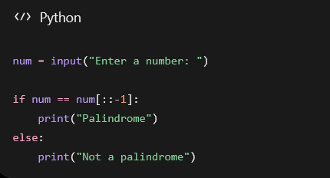
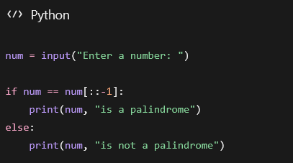
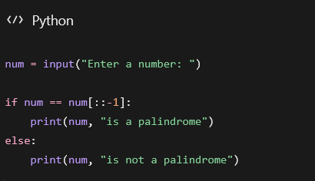

RESULT
The same task is presented through Zero-shot, One-shot, and Few-shot prompts so that their outputs can be compared objectively. The output image area can be used to place screenshots of the three LLM responses and their evaluation.

